**LetsUpgrade Linux Administration Essentials Course Batch 1**

**Assignment Day 3 | 2nd December 2020**

Student Name: Kartick K

Email-id: [kartickkripa@gmail.com](mailto:kartickkripa@gmail.com)

**Assignment:**

1.Create a blank file named "myfile"

2. Open "myfile" in vi editor

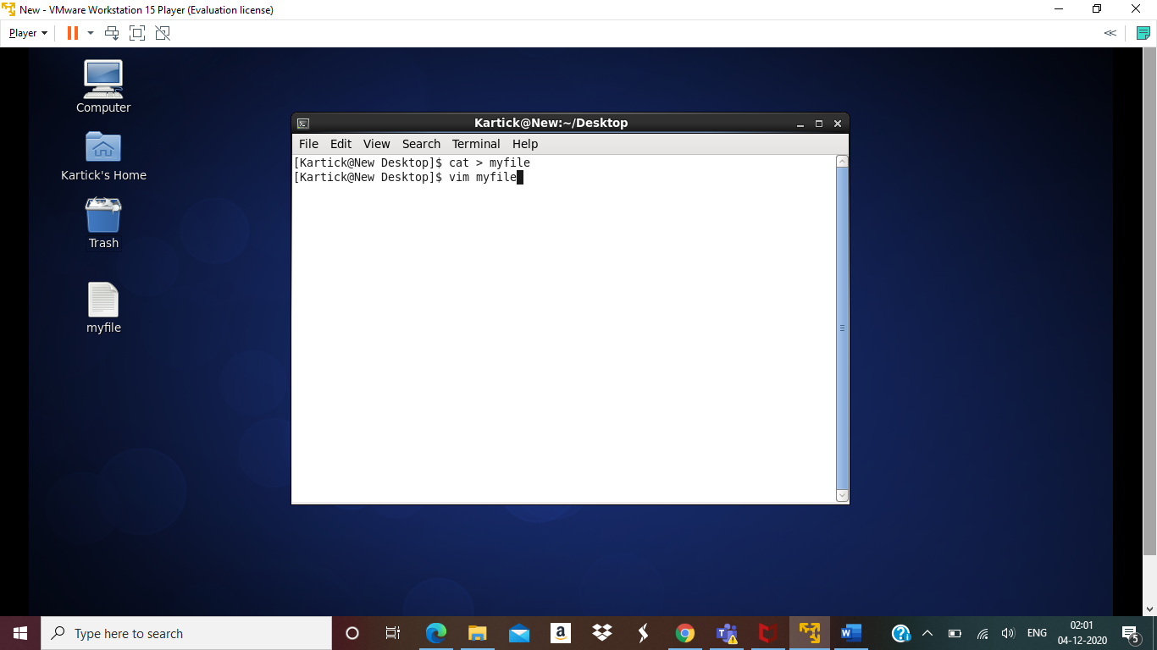

3. Write your name, address, email id, phone number and blood group in 5 different lines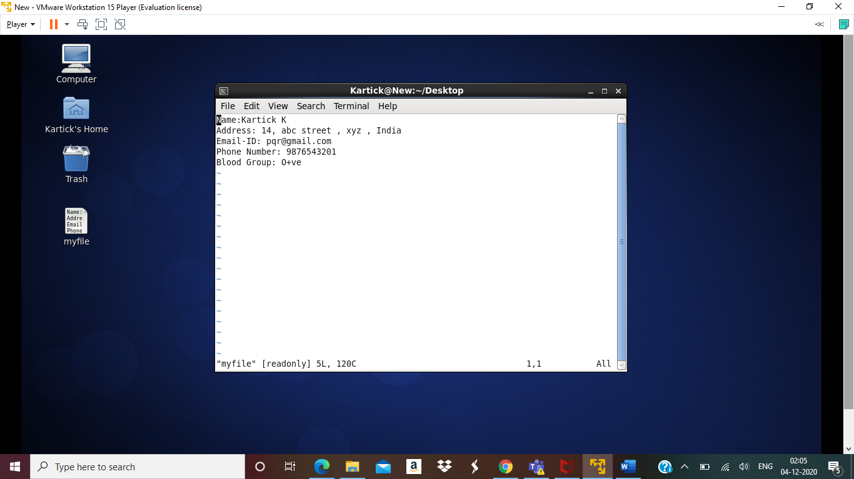

4. Build one single expression to see the line with your name and blood group in myfile

